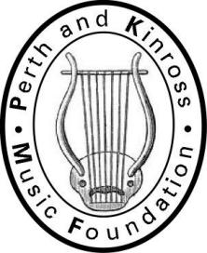**P & K M F**

**“…letting our children play…”**

**Patron: Donald Maxwell**

Application for P&KMF Financial Assistance 2024-25

**Please complete this form with all relevant information, to be submitted to the Secretary (address at the bottom of this page) as soon as possible. Thank you**

|  |  |  |
| --- | --- | --- |
| Your Name |  | |
| Your Address |  | |
| Your Telephone Number |  | |
| Your Mobile Number |  | |
| Your email Address |  | |
| Your Child’s Name |  | |
| Your Child’s Instrument |  | |
| Your Child’s School |  | |
| **I am applying for financial assistance with Central Groups fees** | | |
| **I attach:** | | |
| My HMRC Working Tax Award / Child Tax Credit Award/Universal Tax Credit Statement | |  |
| Other relevant evidence of income for 2024-25 | |  |
| **Is there any other relevant information you wish to tell us about:** | | |

**Signed: Date:**

**Please scan this form and all supporting documentation and email to**:

sheila.herron62@gmail.com. If you do not hear from me within two weeks of emailing please phone me on 01577 864015, if necessary, please leave a message. Thank you.