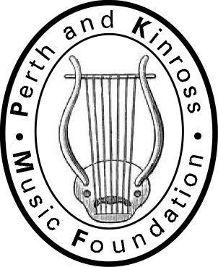
P & K M F
“…letting our children play…”
Patron: Donald Maxwell

GIFT AID DECLARATION
I am a taxpayer and would like the charity to treat all donations I have made in the current tax year and all donations I make from the date of this declaration, until I notify you otherwise, as Gift Aid donations.

I have read the notes set out below.

Signature of donor:

Date: / /

Notes
- You can cancel this declaration at any time by notifying the Treasurer

- You must pay an amount of Income Tax and/or Capital Gains Tax at least equal to the tax that Perth and Kinross Music Foundation will reclaim on you donation in the tax year.

- If your circumstances change and you no longer pay Income Tax and/or Capital Gains Tax at least equal to the tax that Perth and Kinross Music Foundation will reclaim on your donation in the tax year, you must ask us to cancel your declaration.

- If you pay tax at the higher rate you may be able to claim further tax relief in your self-assessment tax return.

- Please notify the Perth and Kinross Music Foundation Treasurer if you change your name and address. All donation enquiries, please, to the Treasurer: Neil Copland by post or email via secretary@pkmf.org.uk. Thank you.

P & K M F
“…letting our children play…”
Patron: Donald Maxwell

Please complete the details below to enable the Foundation to claim Gift Aid on your donation. Thank you.

Title: _

Forename(s):

Surname:

Home Address:

Postcode:

Telephone:

Email Address:

I am interested in becoming a Friend of the Foundation

Thank you for considering donating to the Perth and Kinross Music Foundation. Cheques should be made payable to: Perth and Kinross Music Foundation and sent to our Treasurer, at the address below.

